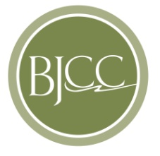
Birmingham-Jefferson Civic Center Authority
address 2100 Richard Arrington Jr. Blvd North
Birmingham, AL 35203
website www.bjcc.org phone 205.458.8400

ADVERTISEMENT FOR PROPOSALS

The Birmingham-Jefferson Civic Center Authority requests proposals from qualified foodservice contractors to provide:

Food/Beverage Operations Management Contract

Proposal information, requirements, and specifications may be downloaded at www.bjcc.org (click Vendor Information – Open Bids section). There is no charge for downloading proposal documents. Documents may be examined and obtained at the Birmingham-Jefferson Civic Center Purchasing Office, 2100 Richard Arrington Jr. Blvd N, North Exhibition Hall, 3rd Floor, Birmingham, AL 35203.

Proposals must be received no later than September 1, 2017, at the executive offices of Birmingham-Jefferson Civic Center Authority, Attn: Matt Wilson – Director of Operations, 2100 Richard Arrington Jr., Blvd. North, Birmingham, Alabama 35203.

Questions should be emailed to Matt.Wilson@bjcc.org. Telephone inquiries are not accepted.

Sharon Proctor
Purchasing Coordinator
Birmingham-Jefferson Civic Center Authority

